BUG REPORT

**Bug Name:**  Able to add alphanumeric characters when it starts with a number  
**Severity:** High  
**Priority:** High

**Environment:** Windows 10

**Platform**: Chrome

**Description:** Able to add alphanumeric characters when it starts with a number

**Steps To Reproduce:**  
**1)** Copy the URL in IE & press enter   
**2)** Add two number following with special characters .

**Expected Results: Results should display as NaN.**

**Actual Results**: Able to add two numbers addition result is showing.

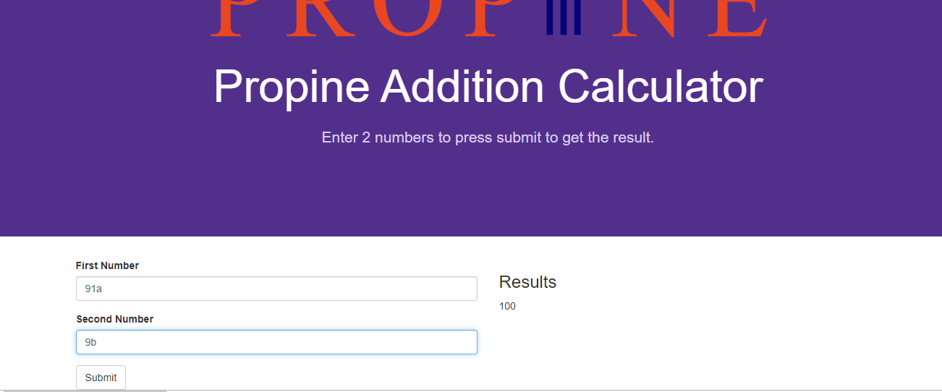

**Bug Name:** UI differrent   
**Severity:** Low  
**Priority:** High   
**Environment:** Windows 10

**Platform** : Firefox , IE

**Description: Submit query button is showing while the URL opening in Internet explorer**

**Steps To Reproduce:**  
**1)** Copy the URL in IE & press enter   
**2)** Propine page should opened

**Expected Results :** Submit button name should be proper

**Actual Results** : Submit button name coming as submit query

